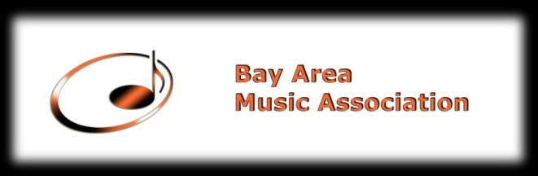

MUSIC LEGACY OPEN COMPETITION
Allegro Music School
1123 Industrial Rd, #300
San Carlos, CA 94070

A. Performer Information
Last Name______________________ First Name __________________________________
Date of Birth___________________Instrument_____________________ Level_________________
Phone Number__________________ Home Address ________________________________ ________________________________________________________________________________
Email Address ____________________________________________________________________
How did you find out about our Competition
Acknowledgement/Agreement: When entering Music Legacy Open Competitions, the participants agree to allow BAMA to obtain photographs and videos that may be used by the BAMA for any purpose and without compensation.
Parent Signature__________________________ Date_________________________________
B. Music Information (Please consult music instructor for information)
Full title of piece___________________________________________________________________
Movement(s)______________________________________________________________________ ___________________________________________________ ________________
Composer__________________________Catalog Number______ ___________________________
Key___________________Length minutes:_______seconds:______Please do not guess.

Full title of piece___________________________________________________________________
Movement(s)______________________________________________________________________ ______________________________________ _________________________________
Composer__________________________Catalog Number_________________________________
Key___________________Length minutes:_______seconds:______Please do not guess.

C.Instructor Information
Last Name________________________First Name_______________________________________
Phone Number_______________________Email_________________________________________
_______________________Home/Studio Address________________________________________
________________________________________________________________________________
Signature____________________________________Date_________________________________

Please Note the Application Fees is Non-Refundable

Please make checks payable to Bay Area Music Association
Mail the complete application to:
Bay Area Music Association
P.O. Box 2344
Daly City, CA 94017-2344

