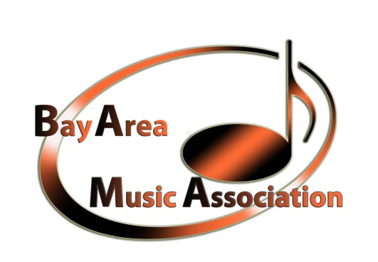

Donation Form

Yes, I want to be part of the BAMA Foundation Family.
Please accept my donation as indicated below.
(Please print or type)

First Name____________________________________ Last Name _________________________
Company Name ____________________________________________________________________________________
____________________________________________________________________________________
City/State/Zip_________________________________________________________________________
Total Amount: $__________________ Check Number: _____________________________________________________________________________________

If you wish for this donation to be made in honor or in memory of someone?
Provide the information hear ______________________________________________________________

Signature ______________________________________________ Date __________________________

Yes, I would like you to contact me regarding a gift of securities
Please make checks payable to Bay Area Music Association
Mail to Bay Area Music Association
P. O. Box 2344
Daly City, CA 94017-2344

Donations are tax-deductible as allowed by law

