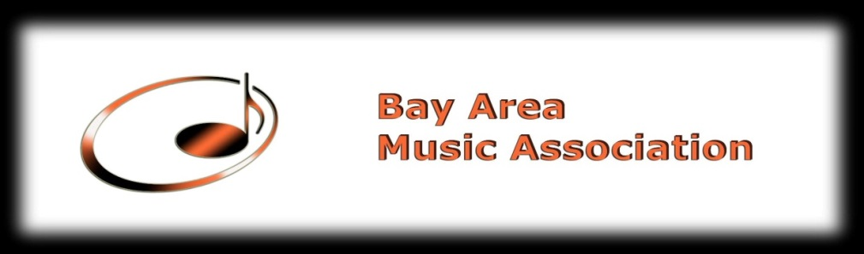
Membership Application
Applicant information
Name
Mailing Address
Email Address
Phone Number
Instrument
Education
Work experience

Signature_______________________ Date__________

Membership fee: $50 per year.
Please make check payable to Bay Area Music Association
Mail the complete application to:
Bay Area Music Association
P .O. Box 2344
Daly City, CA 94017-2344

