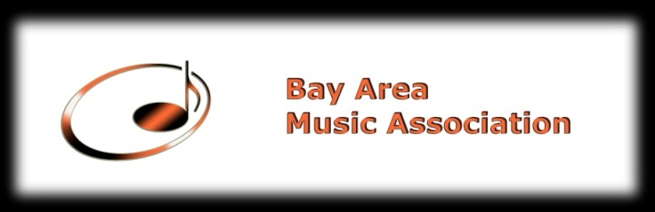
Music Achievement Test
Held at: Allegro Music School, 1123 Industrial Rd., #300
San Carlos, CA 94070
A. Performer Information
Last Name______________________ First Name _______________________________________
Date of Birth___________________Instrument_____________________ Level_________________
Phone Number__________________ Home Address _____________________________________
Email Address ____________________________________________________________________

Parent Signature _________________________Date__________________

B. Music Information (Please consult music instructor for information)
Full title of piece___________________________________________________________________
Movement(s)______________________________________________________________________ Composer__________________________Catalog Number______ ___________________________
Key___________________Length minutes:_______seconds:______Please do not guess.

Full title of piece___________________________________________________________________
Movement(s)______________________________________________________________________
Composer__________________________Catalog Number_________________________________
Key___________________Length minutes:_______seconds:______Please do not guess.

Full title of piece___________________________________________________________________
Movement(s)______________________________________________________________________
Composer__________________________Catalog Number_________________________________
Key___________________Length minutes:_______seconds:______Please do not guess.

C.Instructor Information
Last Name________________________First Name_______________________________________
Phone Number_______________________Email_________________________________________
_______________________Home/Studio Address________________________________________
________________________________________________________________________________
Signature____________________________________Date_________________________________

Application Fee for Music Achievement Test I -$60
Application Fee for Music Achievement Test II- $45

Please make checks payable to Bay Area Music Association
Mail the complete application to:
Bay Area Music Association
P.O. Box 2344
Daly City, CA 94017-2344

