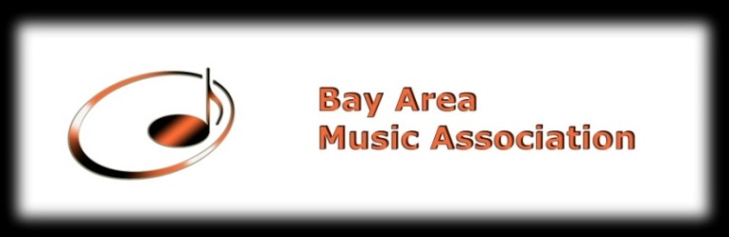

RUSSIAN MUSIC FESTIVAL
October 235, 2016
Held at: Allegro Music School, 1123 Industrial Rd., #300, San Carlos, CA 94070

A. Performer Information
Last Name______________________ First Name _________________________________
Date of Birth _________________Instrument_____________________ Level__________________
Phone Number__________________ Home Address ___________________________________
_______________________________________________________________________________
Email Address ____________________________________________________________________
How did you find out about our Festival
Acknowledgement/Agreement: When entering Russian Music Festival, the participants agree to allow BAMA to obtain photographs and videos that may be used by the BAMA for any purpose and without compensation.
Parent Signature________________________________Date_________________________________

B. Music Information (Please consult music instructor for information)
Full title of piece___________________________________________________________________
Movement(s)______________________________________________________________________ ________________________________________________________________________________
Composer__________________________Catalog Number______ ___________________________
Key___________________Length minutes:_______seconds:______Please do not guess.

C.Instructor Information
Last Name________________________First Name_______________________________________
Phone Number_______________________Email_________________________________________
_______________________Home/Studio Address________________________________________
________________________________________________________________________________
Signature____________________________________Date_________________________________

Application Fees postmarked before October 15, 2016:
Elementary Division: Application Fee $45
Intermediate Division: Application Fee $50
Advanced Division: Application Fee $55﻿
Please add $10 late fee before October 20, 2016.
Please Note the Application Fees is Non-Refundable
Please make checks payable to Bay Area Music Association
Mail the complete application to:
Bay Area Music Association
P.O. Box 2344
Daly City, CA 94017-2344

